 ESIEE Paris

Department of Computer Engineering

Project E4 for Exchange Students

Platform for the Selecting Scientific Articles for Publication in a Journal

Analysis Report

**Project Group Members**

Mehmet Hasat Serinkan

Zhanna Tursunbekova

**Instructor:** Adrien Ugon

**Contents**

**1 Introduction** 3

**1.1 Title** 3

**1.2 Context** 3

**1.3 The Goal** 3

**2 Current System** 3

**3 Proposed System** 4

**3.1 Overview** 4

**3.2 Functional Requirements** 4

**3.2.1 Grading Skills** 4

**3.2.2 Sending E-mails** 4

**3.2.3 Sending Invitations** 4

**3.2.4 Sending Reminders** 5

**3.2.5 Downloading and Uploading PDFs** 5

**3.2.6 Grading a Paper** 5

**3.2.7 Making Rankings** 5

**3.2.8 Making a Proposition** 5

**3.3 Non-functional Requirements** 6

**3.3.1 Performance** 6

**3.3.2 Portability and Compatibility** 6

**3.3.3 Reliability, Maintainability and Availability** 6

**3.3.4 Security** 6

**3.3.5 Usability** 7

**4 System Models** 8

**4.1 Use-Case Model** 8

**4.2 Object and Class Model** 9

**4.3 Schema of the Database** 10

**4.4 Login Activity Diagram** 10

# **1 Introduction**

## **1.1 Title**

Development of a Platform for The Process of Selecting Scientific Articles for Publication in a Journal

## **1.2 Context**

The International Association of Medical Informatics publishes a journal each year which contains, among other things, the best articles in the discipline in 13 different sections. The process of selecting these best articles is done in several stages. Section editors make an initial selection of articles (between 10 and 15 per section). These articles are then evaluated by reviewers (evaluators) with a predefined form. There are several types of assessments, depending on the profile of the assessor. The result of these evaluations is used to determine a score, which is used to classify scientific articles. This ranking, ratings and reviewer comments allow section editors to make their final choice of the best article(s) in their section. The confirmation is made during a final jury of the editorial committee bringing together all the sections.

As editorial assistant for the selection of the best articles, Adrien Ugon is responsible for supporting the selection process. Its role is to find reviewers, support section editors in the submission of the first selection of scientific articles, assign them to reviewers, collect reviews, generate rankings and finally, help with the final selection of the best articles.

## **1.3 The Goal**

The goal of this project is to develop a web platform adapted to the need described above to facilitate the work.

# **2 Current System**

The current system for the process of selecting scientific articles for publication in a journal is done by Easy Chair. Their publication services are integrated with conference management, thus providing a process of submission-to-publication of reviewed content. However, it does not provide a free service. We will try to combine the existing ones and implement new ones to make everyone’s life easier.

# **3 Proposed System**

## **3.1 Overview**

The platform for the process of selecting scientific articles for publication in a journal is an all-in-one web-based application that will help reviewers, section editors, chief editors, vice presidents, selection assistant editors and all other users who are involved in the procedure for selecting articles. The main input data sources of this system will possibly be the scientific articles. There will be different tabs for different functionalities:

## **3.2 Functional Requirements**

### **3.2.1 Grading Skills**

The reviewers should have the ability to grade their skills in 13 different sections. For each skill they will choose between 0 and 10 points. Each skill corresponds to a section with the pool of papers. This information will be used to distribute reviewers into sections and assign the papers to them.

### **3.2.2 Sending E-mails**

It will be possible to send emails to the new and existing users with the platform. The email types include invitations and reminders. Selection assistant editors will be able to add email addresses of external reviewers to the pool of email addresses used by the platform.

### **3.2.3 Sending Invitations**

The platform will generate the invitation emails with the link to the sign-up page and a short guidance on how to use the platform and will send them to external reviewers using the pool of email addresses. This feature will automate the process of inviting new external users to the platform.

### **3.2.4 Sending Reminders**

The reminder email type will be used by the Selection assistant editor to inform users to submit the reviews form of the papers. The platform will generate the reminder email with the link to the platform and information on the papers that need to be reviewed and the deadlines. This functionality will alleviate the work of the Selection assistant editor and speed up the process of collecting the reviews.

### **3.2.5 Downloading and Uploading PDFs**

All the papers will be uploaded to the platform by the Selection assistant editor as “pdf” files, so data inside these files will not be extracted and processed in the database. The users of the platform will have the ability to download these “pdf” files to read the paper and submit the review form. Only the Selection assistant editor will be able to upload or remove the files from the platform.

### **3.2.6 Grading a Paper**

There will be two types of grading forms. First type is a full review form which is dedicated to the external reviewers and section editors. It asks to grade the paper in ten different fields by choosing from 0 to 10 points. The second type is a light review form which is designed for the Chief Editors and the Vice presidents. It will have just a couple of questions with “no or yes” type of answers.

### **3.2.7 Making Rankings**

The platform will prepare a ranking of all candidate best papers grouped by the sections and automatically generate the table with titles, authors and scores. This table will be used by the Selection assistant editor to prepare a proposition of publications.

### **3.2.8 Making a Proposition**

This functionality will be used by the Section editors to prepare a proposition of the best papers of their sections. The proposition will include the first two papers from the ranking list of the section with a short description such as surname of the author, title and evaluations of the paper.

## **3.3 Non-functional Requirements**

### **3.3.1 Performance**

The performance of the website is one of the most important issues. We will aim for the website to be loaded in 2 seconds when the simultaneous user count is less than 5.000. If the simultaneous user count exceeds 5.000, the time for the loading website will be closer to 4 seconds as the user count closes to the 20.000 limit. To accomplish that, the application must have small-sized image extensions like “.webp” and a well-organized database.

### **3.3.2 Portability and Compatibility**

The application must be able to be implemented on different browsers at any time. When the users use the application through A browser and change the browser to B, the application must behave in the same way on browser B. Also, It is considered that the application must use new libraries and frameworks which make the application useful and easily understandable. So, the versions of browsers that our application can be implemented on are listed below:

* Chrome (version 49) (release: 2016)
* Firefox (version 50) (release: 2016)
* Safari (version 10) (release: 2016)
* Internet Explorer (version 10) (release: 2012)
* Edge (version 14) (release: 2016)

### **3.3.3 Reliability, Maintainability and Availability**

Our application will be performed with success in 95 percent of the general use cases and success in 99 percent of the most important use cases such as approving or rejecting cases. If the application is in a failure, the time to fix it must not be greater than 1 hour. The users can access our web application at any time every day.

### **3.3.4 Security**

The information stored in our database must be encrypted to be sure about their security. Every encryption and decryption algorithm will be generated randomly to be specific for that user. There must be one base secret key for implementing encryption and decryption, but every user's secret key must be randomly created from this key. Because every user has a different secret key, even if one user's encryption method is exposed, other users' data must remain safe. The ability to access the database must be authorized to people who have an "Admin" role. In addition to this, the application must store log records on the database.

### **3.3.5 Usability**

Our application must be useful to new users. Therefore, the designs of the pages must be easy to understand and use. The “Exchange” application must meet this need by designing the pages according to new generation methods such as “Tab Bar Menu” and “Pop-up Menu”. In this way, the users can see whatever they need without any detailed search. Also, the application must have different interfaces for different authority levels to go away any kind of complication. Most used functions of the application must be located in the main perspective of the user’s view on the pages.

# **4 System Models**

## **4.1 Use-Case Model**

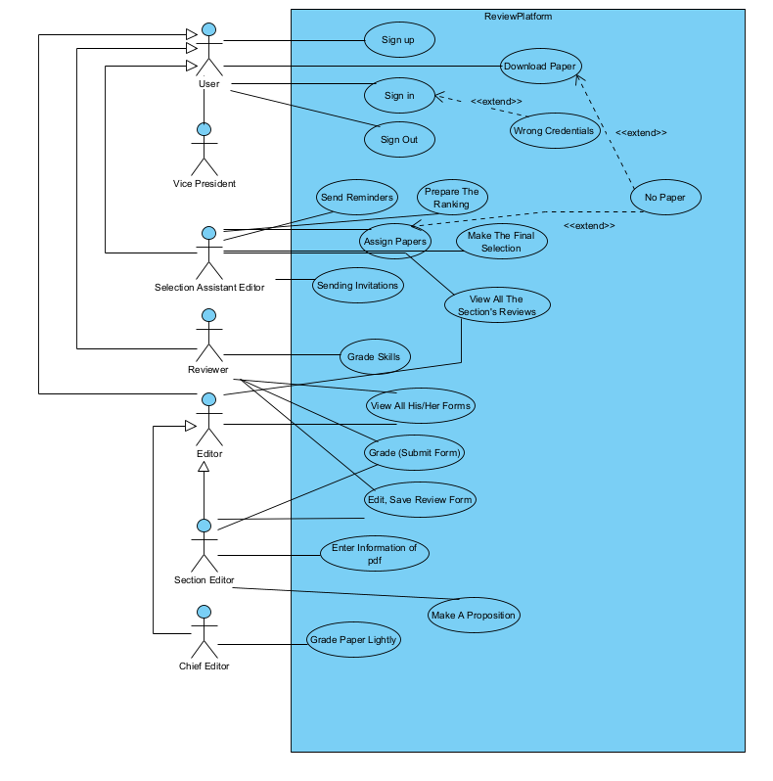

*Figure 4.1.1 Use Case Diagram*

## **4.2 Object and Class Model**

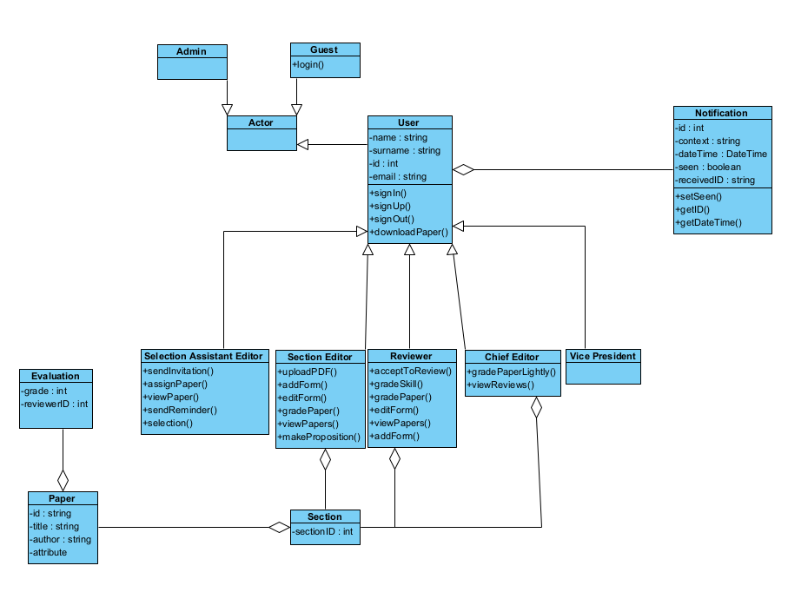*Figure 4.2.1 Class Diagram*

## **4.3 Schema of the Database**

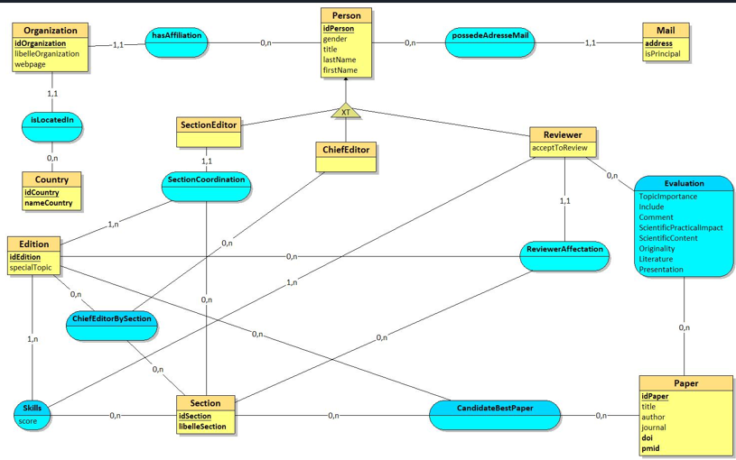

*Figure 4.3.1 Schema*

## **4.4 Login Activity Diagram**

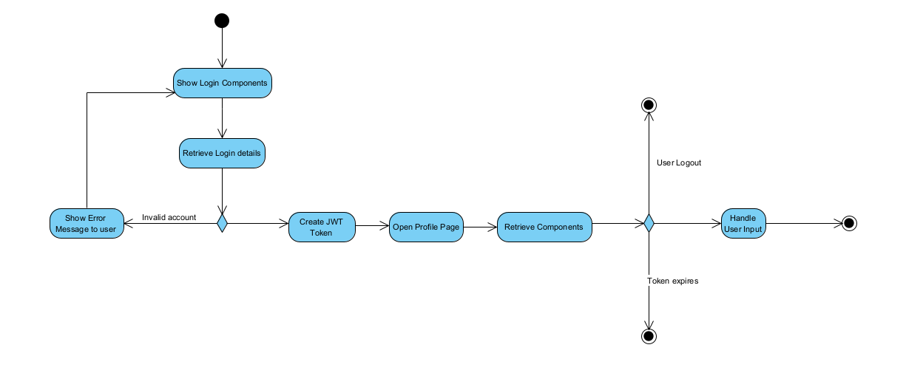

*Figure 4.4.1 Login Activity Diagram*